Usage Instructions

Starting the GUI based planner (run this from the terminal window):
run ‘/RRAD/src/gui_launch/launchBackend.bash or VizlaunchBackend.bash’
launchBackend returns true values that are too low for effective visualization
VizlaunchBackend returns less accurate values, but more effective visuals
TestlaunchBackend launches a test version of launchBackend so that no changes need to be made to the current build

This opens all of the needed files for the backend
(any filename changes need to be reflected in these files as well)

Open /RRAD/src/gui/FrontEnd/Godot_v2.1.4-stable_x11.64 to start GODOT
(launch this from the the file explorer)
this should open a selection box to select the same file within GODOT
open the file and then click the ‘play’ button to begin

After pressing play in GODOT, a file selection dialog box is opened as shown below. From here, you can select any STL file located anywhere on the machine.

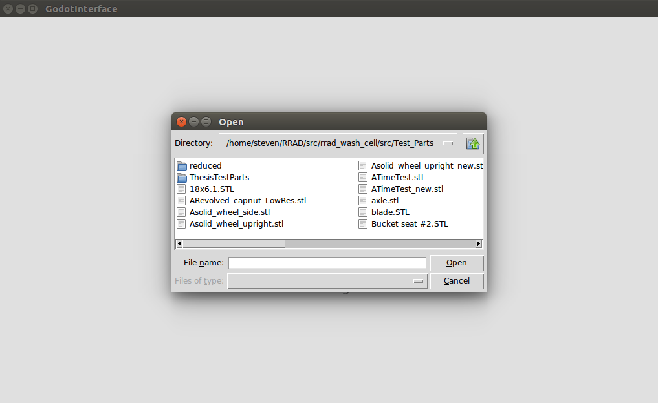
Once a file is selected it may be displayed in a simple python generated window (this can be commented out in the code) for verification. This window must be closed to continue.

The process selection dialog box is then displayed as shown below:

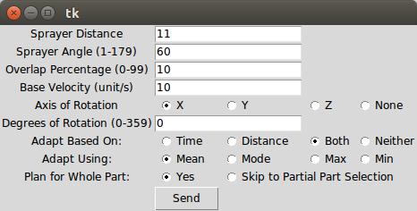
This allows the user to select the various parameters of the process. The default settings are shown above and can be adjusted in the code.
This window can also be modified in the code to add more features if needed. Currently, the Skip to Partial Path Selection does not work due to how GODOT interprets no path, but the functionality is there if an acceptable null path can be created.

Once all options have been selected, hit send to start the path planner. There will be some wait time depending on the part and the parameters selected. Progress can be seen in the terminal windows.

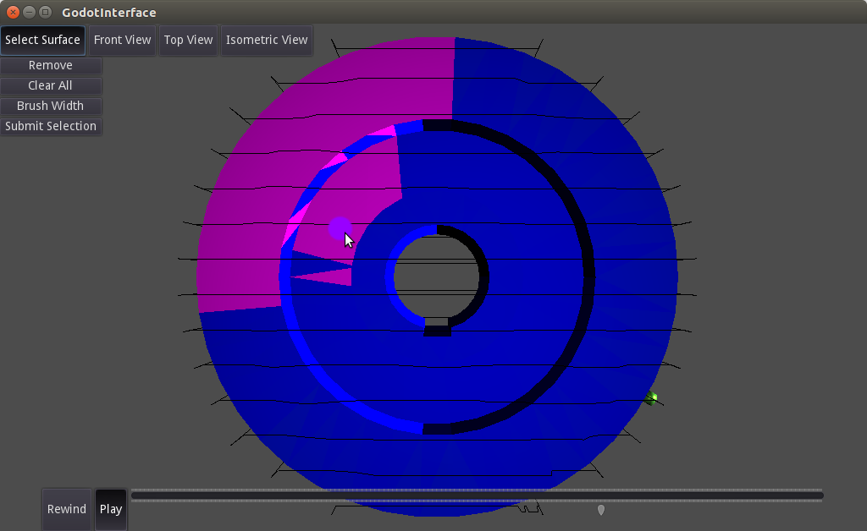
The resulting path is then displayed in GODOT and is ready for user interaction as shown above. Right clicking allows for camera rotation, scroll controls zoom and predefined camera angles can be selected via the top buttons. Play/Rewind work to control direction of sprayer movement long the path as well as functioning as pause buttons. The slider can be used to move to a specific part of the path. Rework areas or partial paths can be selected by clicking on Select Surface. This opens a drop down menu and changes the pointer to a selection brush. Clicking and dragging will select/highlight facets, Remove changes the brush to remove facets from selection in the same manner as adding facets, Clear All removes the entire selection, Brush Width opens a slider that allows for control of brush size, and Submit Selection sends the data to the planner for rework. From here, there will be some wait time, but progress can be seen in the terminal windows. This process should be able to be repeated for multiple rework areas, although GODOT is known to randomly crash at times.

